**PRACTICAL 4**

**Database Management Systems**

|  |  |
| --- | --- |
| **NAME: VARUN KHADAYATE** | **ROLL NO: A016** |
| **PROGRAM: BTECH SY** | **DIVISION: CSBS** |
| **BATCH: 1** | **DATE OF EXPERIMENT: 01/03/2021** |

# AIM

To understand and implement Transaction Control Language (TCL) Statements.

# THEORY

## 1] COMMIT

Commit command is used to permanently save any transaction into the database. When we use any DML commands like Insert, Delete or Update, the changes made by these commands are not permanent, until the current session is closed, the changes made by these commands can be rolled back. To avoid that, we use the Commit command to mark the changes as permanent.

### Syntax:

commit;

When we use this command then all the records that currently exist in the database will be stored permanently.

Once this command is used, we cannot rollback data again.

Once we use this command, in all current data of table EMP will be permanently stored in the database.

## 2] Rollback

A Transaction can be closed by using a rollback statement. By using these statements, table data can be changed, or all the changes made to the table data undone.

It ends transaction but undoes any changes during the transaction.

### Syntax:

rollback;

# CODE SNAPS

## Creating the Table and Viewing it

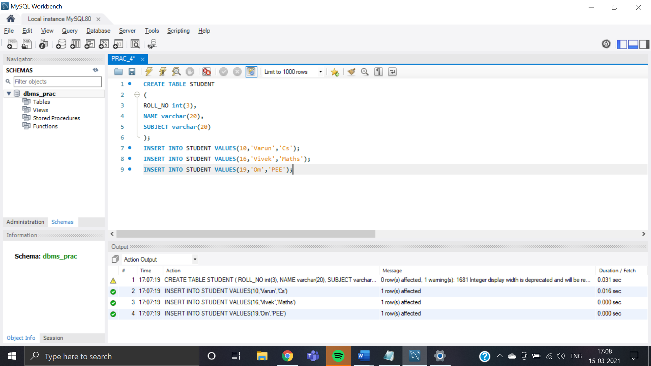

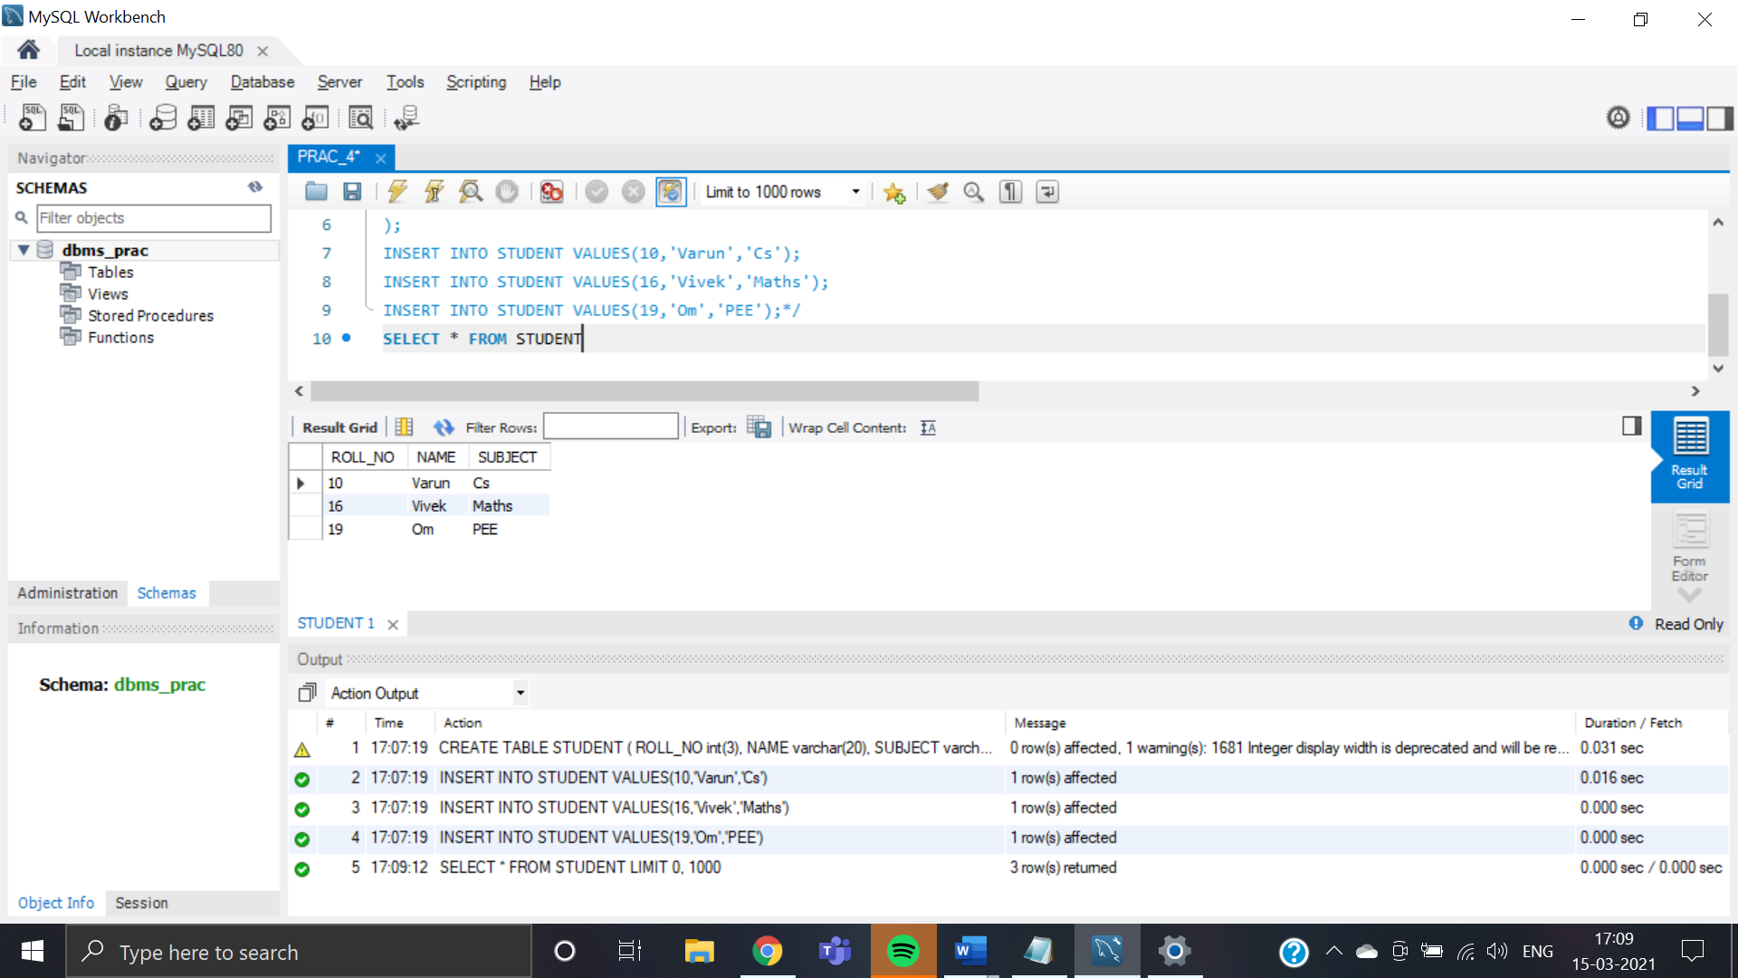

## COMMIT

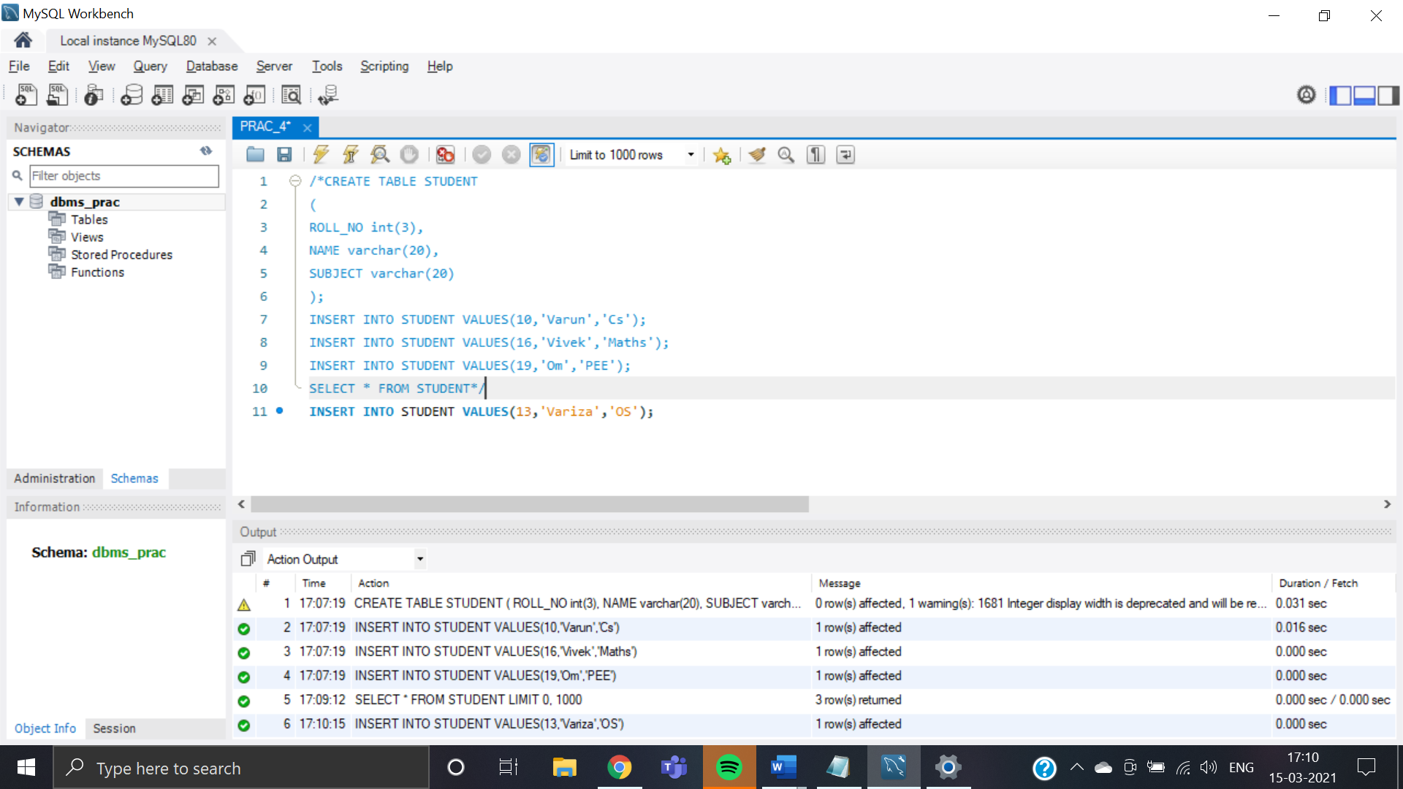

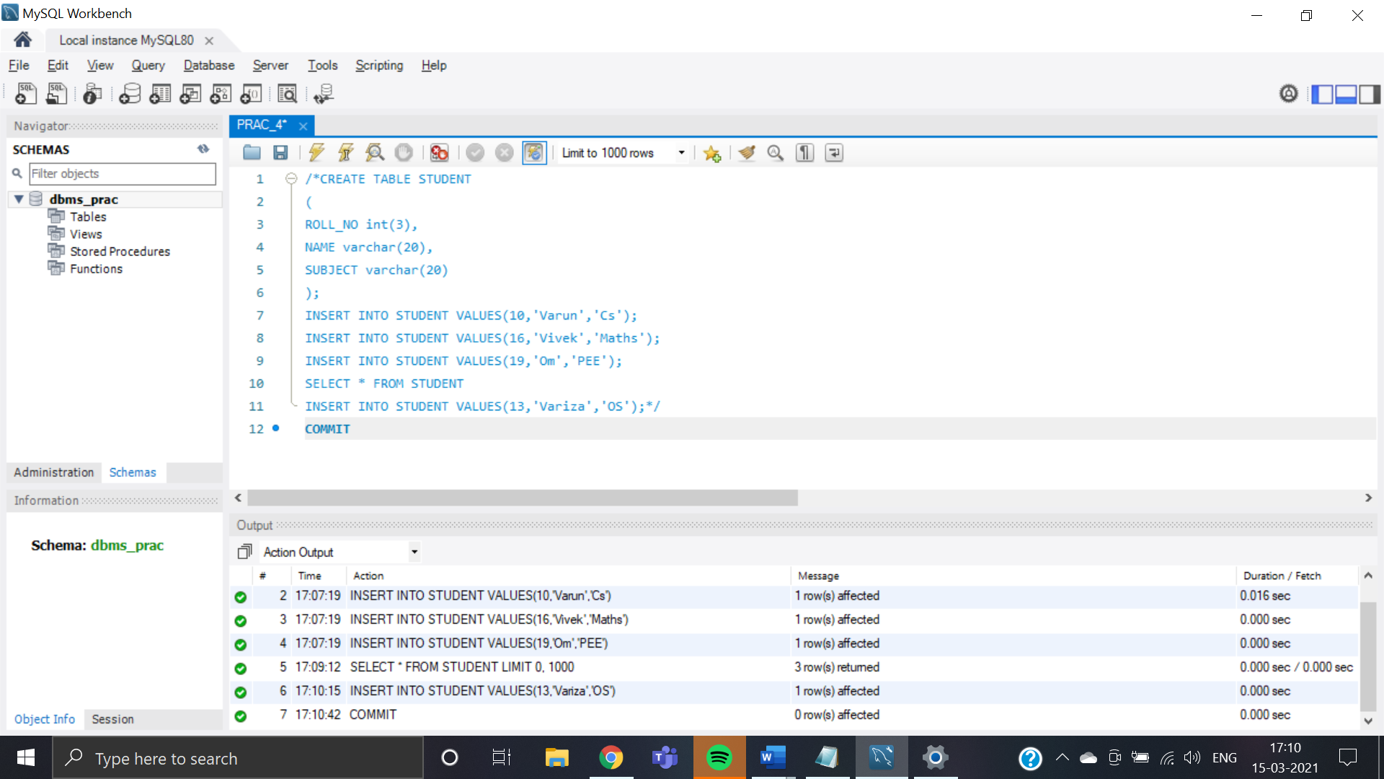

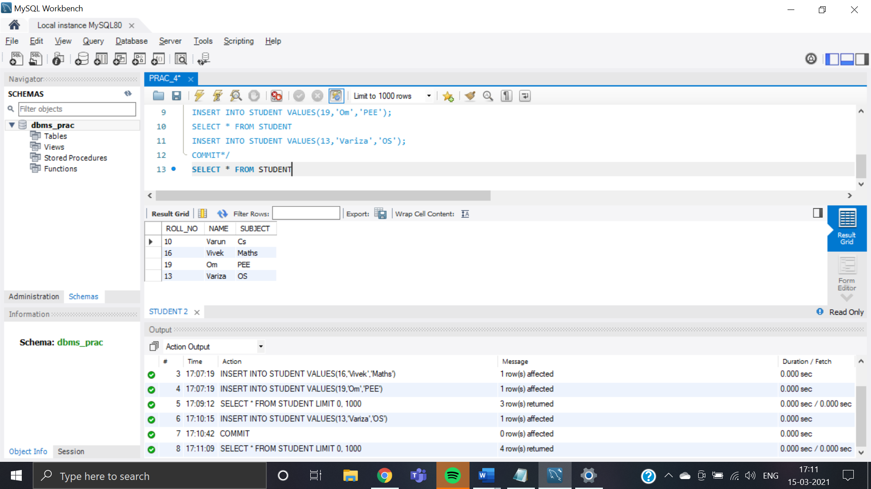

## Rollback

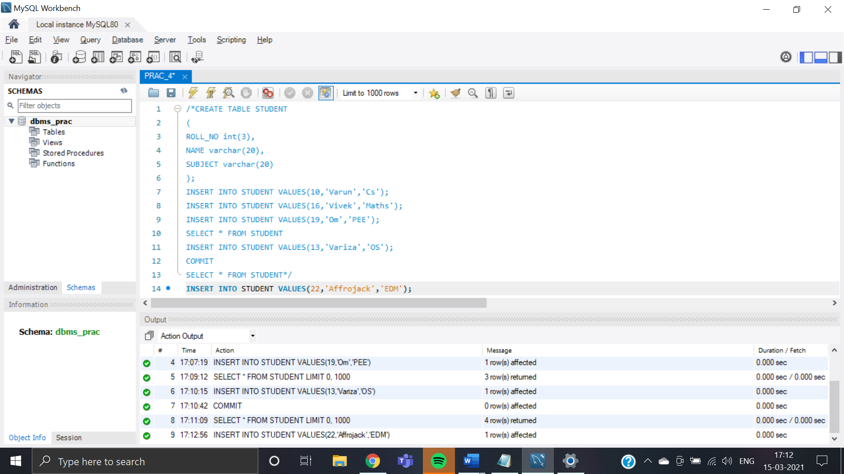

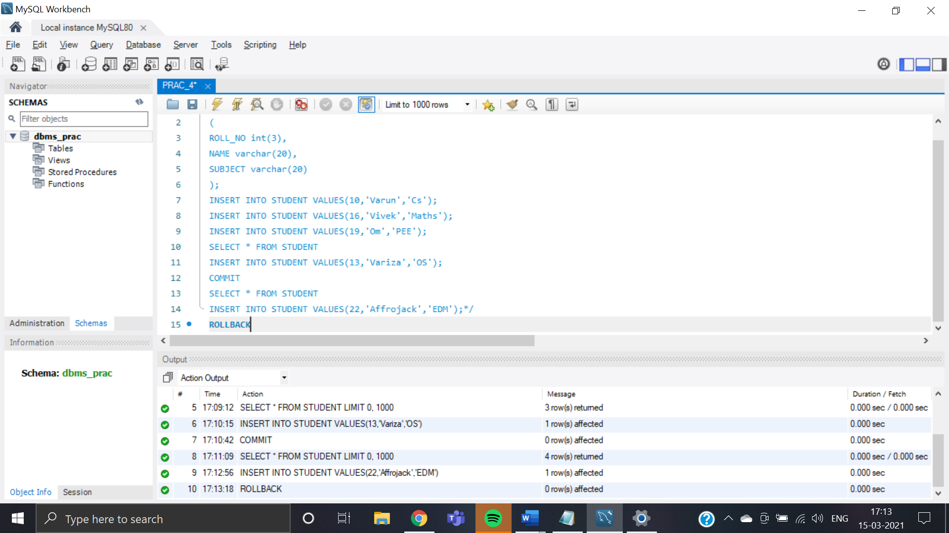

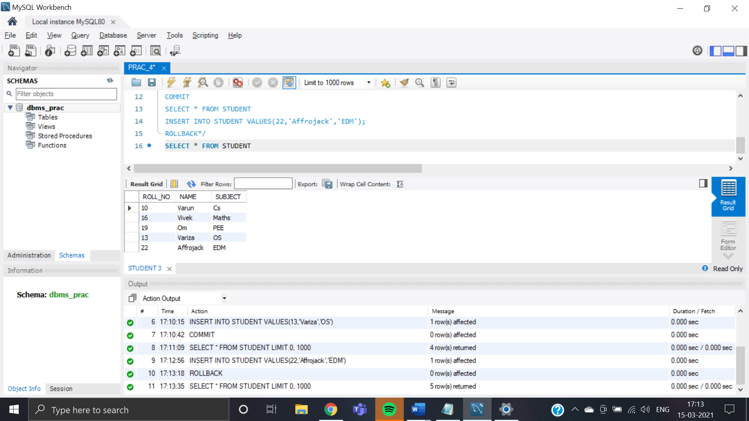

# CONCLUSION

We were able to have a practical experience of how transactions could be made permanent in memory or how are they revoked.